Lab 2
PLC Commands and Tag Naming Conventions
Seth Ricks
10/27/2026
ECEN 470

Objectives
Learn the basics of Factory Talk and Studio 5000, and how to communicate with the school’s CompactLogix Allen-Bradley machinery.

Task 1:
- Use Factory Talk to properly connect to the Allen-Bradley controller, using the IP-address inscribed on the casing.
- Create a new program and discover backplane modules.
Task 2:
- Ladder Logic: Control LED 1 using Switch 1
Task 3:
- Structure Text: Control LED 2 using Switch 2
Task 4:
- Sequential Function Chart: Control LED 3 using Switch 3
Task 5:
- Function Block Diagram: Control LED 4 using Switch 4
Task 6:
- Combine subroutines 2-5 to create a main program, and run on the controller

Procedures

Equipment and supplies
- A school computer with Studio 5000 and FactoryTalk installed, and an Allen-Bradley CompactLogix controller.

Task 1:
The first thing that needed to be done was connect to the Allen-Bradley controller. This proved to be more complicated than expected, as the network used to connect to the controller was shared with the rest of the class. Another team was attempting to access the controller assigned to us remotely on the same network. Subsequently, when we attempted to connect to the IP-address inscribed on the casing of the controller (10.22.166.110), we received errors that the controller couldn’t resolve the current program. It wasn’t until that team informed us that they were having the same issue that we were able to connect to the controller.
To ensure that we had connected to the controller properly, we attached a value to a local tag. This can be seen in Figure 1 below. When we changed the value of ‘LED_1,’ the corresponding LED attached to the controller was illuminated. Likewise, when we flipped the switch corresponding to the signal ‘Switch_1’ the tag value changed.

Figure 1: Manual Tag Observations

To complete the rest of the tasks, we had to create aliases for the other LEDs and switches. This can be seen in Figure 2 below. Each corresponding name relates to a particular I/O signal to the controller. We can use these names later to directly and automatically control these values in code, rather than manually changing them.

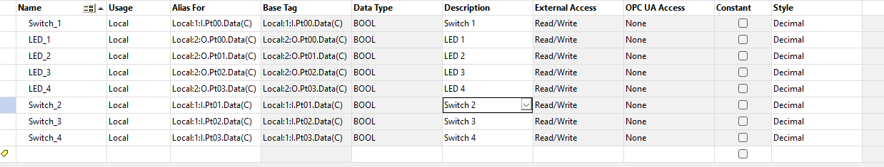
Figure 2: Aliases for Controller I/O Data Ports

Task 2:
As noted previously, our first task after the initial configuration was to control LED 1 with Switch 1, using ladder logic. This was done by right clicking on the main program file and creating a new subroutine called ‘Control_LED1.’ An image of the ladder logic program can be seen in Figure 3 below. It is quite simple, directing the logical signal of Switch 1 directly into LED 1.
The functionality of this program was confirmed by manually toggling switch 1 and observing the behavior of LED 1. This was also confirmed by the green illuminated values in the ladder logic, as noted in the figure.

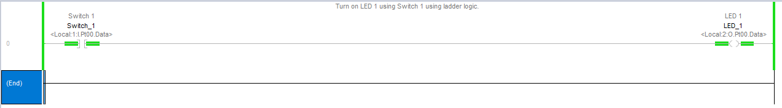
Figure 3: LED 1 Control with Ladder Logic

Task 3:
The second task was to do something very similar, but with Switch 2 and LED 2. The major difference is that this time, the logic will be implemented with structure text. This code can be seen in Figure 4 below. Rather than being a strictly visual representation of the logic, this method includes lines of code like any other sequential programming language. The logic in our code is simple, with an if statement on the condition of the value of Switch 2, and the logic in each condition being the value of LED 2.

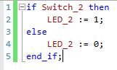
Figure 4: LED 2 Control with Structure Text

Task 4:
Next, we were tasked with creating similar logic for Switch 3 and LED 3. To do this, we were to create a sequential function chart routine. This task proved to be the most difficult to implement and understand. This design represents a signal flow from the controller itself. Our design can be seen in Figure 5 below. Transitions, represented by ‘Tran’ in the figure, are the conditions for the logic to move forward. The actions are what happens when the controller is in each state. In principle, this program is like how a state machine works, with flow through the branches of the machine dependent on the current state of the controller.
First, the controller enters the routine from the top. Then, based off the value of switch 3, the logic can either flow to the right or to the left. From this, one of two things can happen. If the left path is entered, the action is to assign the value 1 to LED 3, effectively turning it on. If the right path is entered, the action is to assign the value of 0 to LED 3, effectively turning it off. After each of these actions, a transition node is placed with an always true value, as the syntax of this code is that steps must always be in between transitions.

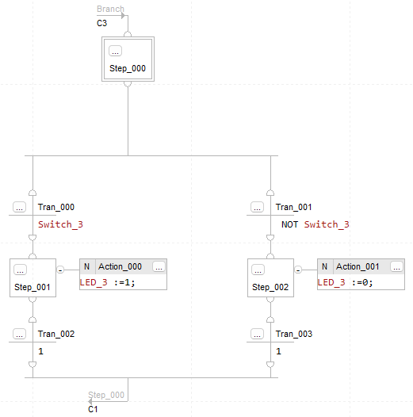
Figure 5: LED 3 Control with a Sequential Function Chart

Task 5:
The last subroutine we created was for LED 4, controlled by switch 4. This routine is created with a function block diagram, which was by far the simplest. An image of it can be seen in Figure 6. It consists of only two nodes: Switch 4 and the LED 4. It is like LabVIEW, in that the inputs and outputs are graphical, and that connecting them together is akin to connecting them with a physical wire.

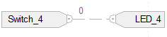
Figure 6: LED 4 Control with a Function Block Diagram
Task 6:
After creating the above subroutines, all that was left to do was combine them into a single main program. This can be seen in Figure 7. As shown in the figure, the routines that were created in tasks 3-5 are implemented as JSRs (Jump to Subroutine) on the right side of the ladder logic. The controller implements these sequentially, but fast enough to not be perceived when compared to how fast a human can move one of the switches. Thus, with all these combined, it is time to test if it works.

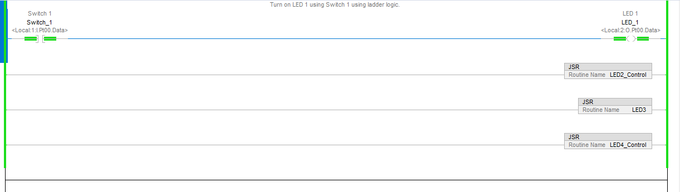
Figure 7: Main Routine with JSR Ladder Logic

To test the functionality of our program and the related subroutines, it was simply a matter of toggling the switching manually. Figures 8 depicts this, with the first showing the state of all the switches on, and the second with all of them off. Although the figure shows all the switches in identical positions, each enabled switch corresponds to the related light being illuminated.
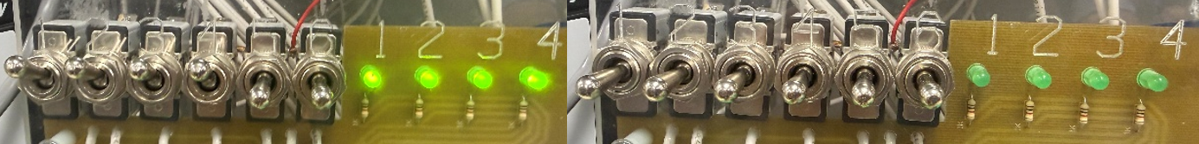
Figure 8: Manual Test of Switches Controlling LEDs

Conclusion

The program worked as desired, but the purpose of this lab wasn’t to learn how to control lights. Rather, it was to learn the somewhat complicated interface of the Studio 5000 and FactoryTalk with the CompactLogix Allen-Bradley controller.
The most important thing that I learned was how to use this system to connect to the controllers in the lab, and the different kinds of logic that they accept. The different kinds of routines that can be written for this controller are: ladder logic, structure text, sequential function chart, and function block diagram. Each seems to have their benefits and downsides. Some are easier to understand in small amounts, such as the function block diagram, but I imagine would become more cumbersome to navigate once the logic becomes heavier. On the other hand, some structures seem more complex at first, such as the structure text, but might be easier once there is a lot of logic. My personal observations on the possible strengths and weaknesses of these methods are shown in Figure 9 below. I think that the interpretation of these methods will be very useful for us in future labs, where we might have to decide for ourselves what method to use. We can look at this table, decide what type of problem we have, and plan our method accordingly.

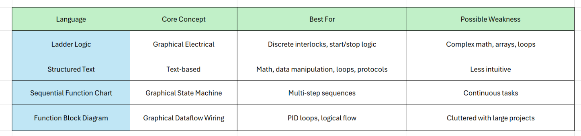
Figure 9: Interpretation of the Controller Languages

